From: Aleksandrov Aleksey Valerievich
Sent: Tuesday, November 05, 2013 10:25 AM
To: Terentev Aleksey; Belogrud Sergey Vladimirovich
Subject: Сохранение данных из iLO

1. dd if=/dev/zero of=/tmp/hp.img bs=1M count=100
2. mkfs.vfat /tmp/hp.img
3. Забираем образ и монтируем его в iLO

Данные получить можно при помощи любого архиватора, например 7Zip.

[support@centos00 share]$ dd if=/dev/zero of=to_hp_ilo.img bs=100M count=1
1+0 records in
1+0 records out
104857600 bytes (105 MB) copied, 0.434937 s, 241 MB/s
[support@centos00 share]$

[support@centos00 share]$ mkfs.vfat to_hp_ilo.img
mkfs.vfat 3.0.9 (31 Jan 2010)
[support@centos00 share]$

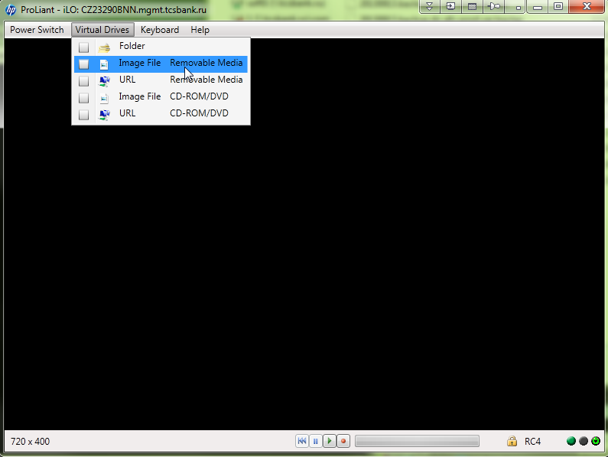

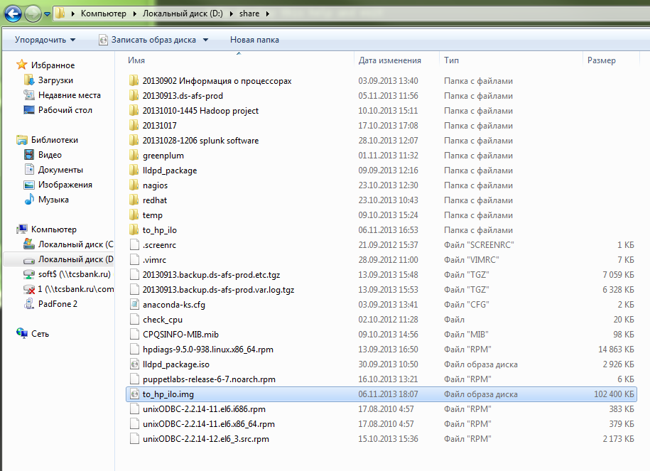

Create Floppy Disk Images from within Linux
Sat, 06/05/2010 - 20:49 — jbreland
It's possible to create floppy disk images (IMG files) from withing Linux using native Linux utilities. Although you most likely won't have a very frequent need for this these days, one place where it can come in handy is when dealing with virtual machines. Emulators such as VirtualBox and VMware Player can mount virtual floppy images and present them to guest machines as physical disks, just as they can mount CD-ROM ISO images and present them as physical CDs.

Now again, there probably isn't a very widespread need to do this, but in my case I needed to be able to create floppy disk images for my Windows installation CD. I use a heavily customized installation CD with an answer file to automate Windows installation. Unfortunately, Windows XP is only capable of reading answer files from the CD itself (which doesn't work for me because I need to be able to change the file) or from a floppy disk. Newer versions of Windows, I believe, can read from USB drives, but as I only (and infrequently) run Windows inside a virtual machine, I don't have any great need to upgrade. Being able to easily generate floppy disk images containing updated answer files, etc. has been a huge help compared to keeping up with physical floppy disks, especially since my current desktop no longer supports a floppy drive. Now, I just point VirtualBox to the appropriate IMG files, and when I boot Windows (or the Windows installer) it'll see it as a normal floppy drive. Very handy.

In order to create floppy disk images, you'll need a copy of dosfstools installed. It should be available in most package repositories. Once installed, the following command does all the magic:

mkfs.vfat -C "floppy.img" 1440

You now have an empty, but valid, floppy disk image. In order to copy files to the image, you need to mount the image using the loop device:

sudo mount -o loop,uid=$UID -t vfat floppy.img /mnt/floppy

Note that the mount command must either be run as root or using sudo; the uid argument makes the mount point owned by the current user rather so that you have permission to copy files into it.

After you're finished copying files, unmount the image and you're done. You can now attach it to your emulator of choice as a floppy disk image. W00t.

To make things even easier, the following script automates the entire process; just pass it the directory containing all of the files you want copied to the floppy disk and it'll do the rest.

#!/bin/bash

# Setup environment
FORMAT=$(which mkfs.vfat 2>/dev/null)
MOUNT=$(which mount 2>/dev/null)
TMP='/tmp'
shopt -s dotglob

# Verify binaries exist
MISSING=''
[ ! -e "$FORMAT" ] && MISSING+='mkfs.vfat, '
[ ! -e "$MOUNT" ] && MISSING+='mount, '
if [ -n "$MISSING" ]; then
echo "Error: cannot find the following binaries: ${MISSING%%, }"
exit
fi

# Verify arguments
if [ ! -d "$1" ]; then
echo "Error: You must specify a directory containing the floppy disk files"
exit
else
DISK=$(basename "${1}")
IMG="${TMP}/${DISK}.img"
TEMP="${TMP}/temp_${DISK}"
fi

# Load loopback module if necessary
if [ ! -e /dev/loop0 ]; then
sudo modprobe loop
sleep 1
fi

# Create disk image
${FORMAT} -C "${IMG}" 1440
mkdir "${TEMP}"
sudo $MOUNT -o loop,uid=$UID -t vfat "${IMG}" "${TEMP}"
cp -f "${DISK}"/* "${TEMP}"/
sudo umount "${TEMP}"
rmdir "${TEMP}"
mv "${IMG}" .

